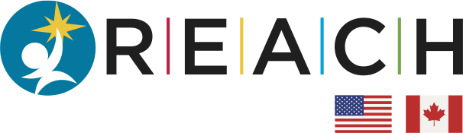

Research, Education and Awareness for Children with Hirschsprung Disease

REACH Fellowship 2023 Application Form

The goal of the REACH Fellowship Program is to attract new talent and promote best practices in the field of Hirschsprung Disease research, diagnosis, and treatment around the world.
The program will begin in 2023. REACH will provide annual funding through a competitive application process. Each year, the program will offer a pediatric surgeon or pediatric gastroenterologist early in their career with an interest in Hirschsprung Disease (HD) the opportunity to travel to a host institution to learn best practices in the diagnosis and treatment of HD. Visits will be 3-5 days in duration.

Application:

The completed application must include:

- Applicant name, institution, and where and when pediatric fellowship was completed
- One page essay explaining:
  - Clinical/research focus
  - Why this fellowship is of interest to you
- Please attach a brief letter from the division chief in support of your application

At the end of the program, applicants are required to:
- Compile a summary report and
- Attend and present at the REACH Virtual Symposium

Please acknowledge support from the REACH on resulting presentations and manuscripts.

Please submit all applications to the REACH Foundation with the subject “2023 REACH Fellowship Application” via email to REACHirschsprungs@gmail.com no later than 5:00pm on May 1, 2023.

REACH Fellowship 2023 Application

Applicant’s Name:
Institution/Hospital:
Where and When Pediatric Fellowship Completed:
Clinical Research Focus:

Why this Fellowship is of interest:

