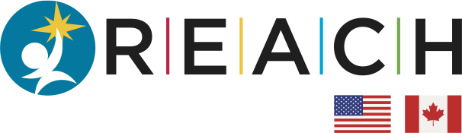

Background: REACHirschsprungs is a 501(c)(3) foundation whose mission is to support Research, Education, and Awareness for Children with Hirschsprung disease. REACH research grants are $30,000 1-year awards intended to support basic, translational, clinical, or epidemiologic research relevant to Hirschsprung disease.
Application deadline: Applications must be submitted electronically by 5:00pm on May 15, 2024. The funding period will be from July 1st, 2024, through June 30, 2025.
Eligibility: REACH grants are made to not-for-profit institutions engaged in health-related research. Applicants from such institutions must hold an MD and/or PhD degree. Only one application is allowed per applicant per cycle. Any research involving human subjects or animals must adhere to ethical standards and be approved by the appropriate institutional review boards. Furthermore, all applicants must adhere to their institutional guidelines regarding conflicts of interest, scientific misconduct, and any other relevant policies and procedures.
Review of Applications: Each application will be reviewed by at least two scientific reviewers with knowledge in the field of Hirschsprung disease. Applications will also be reviewed by at least one lay reviewer, an individual who is neither a scientist nor clinician but has a strong commitment to advancing research in Hirschsprung disease. Proposals will be evaluated based on the following criteria: (1) originality of the idea; feasibility; and quality of the science; (2) experience and track record of the applicant and the investigative team; (3) institutional environment, and; (4) significance of the proposal to impact the field.
Grant payment will be made by check to the institution at the beginning of the funding period.
Final Progress Report: At the completion of the funding period, a progress report is required. In addition, the recipient of the award must provide either a slide presentation or a brief You-tube video summarizing the research and its potential benefits to patients with Hirschsprung disease. The presentation or video will be posted on the REACH website (www.REACHHD.org) so that Foundation donors and visitors to the website are made aware of the research that REACH supports. The final report should include a brief 1-page scientific and nontechnical summary describing the work completed during the period of the award.
Publications: Publications and presentations resulting from research supported by REACH must contain an acknowledgement of the REACHirschsprungs Foundation.
Allowed Expenses: REACH grants can be used to support laboratory supplies, materials, and other resources necessary for performing the scope of work proposed. Salary and fringe benefits of technicians, post-doctoral fellows, and research assistants (but not faculty) are allowed. Total award = $30,000. No indirect costs are allowed.

